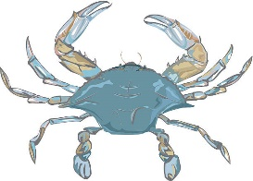 Crab Feast 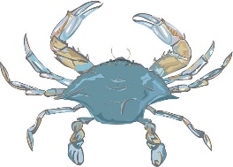
We’re back at Circle D Farm!!
15535 Carrs Mill Rd. Woodbine, MD 21797
Saturday Oct. 30th from 12 – 5
Tickets $50 online advance sales - $60 at the door
$20 - Kids 13 -20 ** 12 and under free!!
Back again this year, $125 Family ticket (on-line only)
Includes both parents and all their kids under 21
(other people’s kids not included)

Crabs from 12-4 or while they last!
Playground for kids
Emerald Haberdashery
Benefits the ES Wounded Warrior Fund
And much more!!
Hamburgers
Hot Dogs
Side Dishes
$10 Beer Bracelets - We have Cans!
We strongly encourage presales or RSVP to Jim Reilley 301-991-0557 or Dick Sterne 301-938-0075
For advance tickets go to www.dcfdemeralds.org

